**UML Diagram for Cell-phone:**

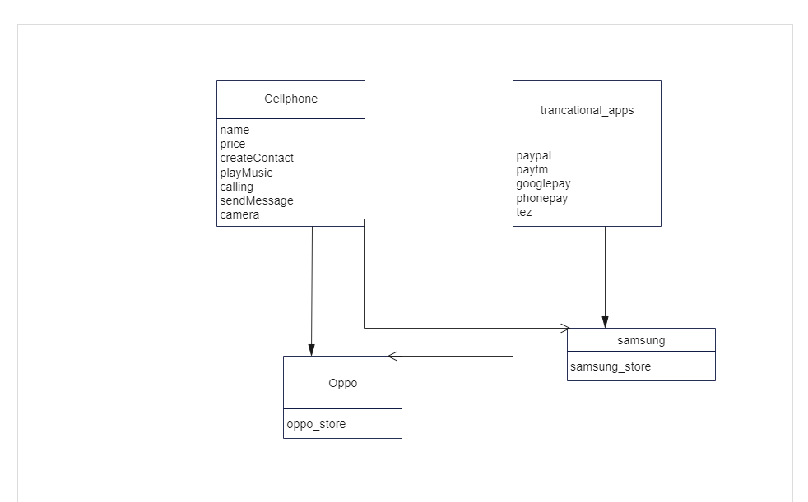

* Here I created cell-phone class as base class so we can derived multiple brands from this cell-phone class.
* I have created two brands Samsung and oppo from cell-phone class and tansactiona_app class.
* This Samsung and oppo can use features (calling,sendMessage,playmusic,camera) of cell-phone class and transactional_app class along with that they can have their own features.(Samsung_store,oppo_store).
* Here I used factory design pattern because with the help of base class we can create multiple brands of cell-phone just by giving different inputs. Like Price, name will be different for different brands.